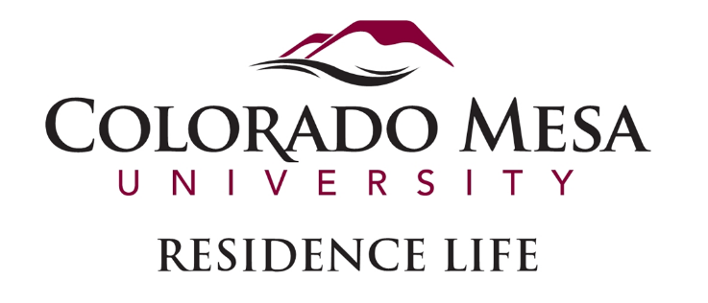

SUMMER CONFERENCE TEAM-LEAD

Position Description

**Position Overview:**

The Summer Camps and Conference Team-Lead serves as a vital student leader within Residence Life, helping to create a positive and welcoming environment for summer conference guests. This role is an excellent opportunity for those interested in developing skills in leadership, supervision, communication, and hospitality management. Reporting to the Professional Staff Summer Coordinator, Team-Leads will oversee a team of 10-12 student staff members, guiding them in providing exceptional service to summer campers, conference attendees, and other guests.

Throughout the summer, Team-Leads will enhance their knowledge of university resources, academic programs, CMU athletics, and local community offerings to serve as mentors and resources for guests. This hands-on experience aims to prepare students for potential careers in student affairs, sports management, hospitality, event management, or related fields.

**Preferred Qualifications:**

* Previous Residence Life, sports management, or hospitality experience
* Strong interpersonal and organizational skills
* Ability to work independently and as part of a team

**Key Responsibilities:**

**Leadership and Supervision**

* Assist in the recruiting, training, and supervising a team of Conference Assistants (CAs), focusing on mentorship, hospitality, conflict resolution, technology use, crisis management, and team building.
* Provide ongoing coaching and feedback to CAs, fostering professional growth and team cohesion.
* Organize and lead weekly team meetings to address concerns, celebrate successes, and strategize for upcoming conferences and events.
* Take a leadership role in coordinating the arrival, check-in, and departure processes for summer camps and conference guests.

**Guest Relations and Customer Service**

* Serve as a primary point of contact for conference guests, ensuring a seamless experience from arrival to departure.
* Address guest inquiries, resolve issues promptly, and act as a liaison between guests and university departments.
* Assist in managing the Summer Conference Office, including handling guest reservations, room assignments, and key card and hard key distribution.
* Implement customer service best practices to ensure high satisfaction among conference attendees.

**Event Planning and Operations**

* Collaborate with campus departments such as Admissions, Athletics, and Facilities to support large-scale events, conferences, and athletic camps.
* Assist with the coordination of logistics for summer programs, such as room setups.
* Assist in overseeing the scheduling and use of university facilities for conferences, workshops, and events.
* Conduct pre-event walkthroughs and post-event evaluations to ensure continuous improvement.

**Administrative and Compliance**

* Uphold all laws, policies, and procedures of the United States, the State of Colorado, Colorado Mesa University, and Residence Life.
* Assist in the development and implementation of safety and emergency protocols, including crisis response and evacuation procedures.
* Monitor the cleanliness, safety, and maintenance of residence halls and event spaces.
* Maintain accurate records of conference activities, guest feedback, and incident reports.

**Professional Development**

* Participate in professional development opportunities provided by Residence Life and other campus departments.
* Reflect on personal growth and skill development throughout the summer, identifying areas of strength and improvement.
* Network with campus professionals to explore potential career paths in student affairs, hospitality, or event management.

**Other Duties as Assigned**

* Support Residence Life staff with various tasks related to summer operations, including inventory management, facility inspections, and administrative support.
* Serve as a positive representative of Colorado Mesa University, embodying the values of inclusivity, service, and excellence.
* Take on additional projects or responsibilities as directed by the Manager of Operations and the Professional Staff Summer Coordinator.
* This position offers a unique chance to gain hands-on experience in leadership, event coordination, sports management, and hospitality management, setting the stage for future career opportunities in a variety of fields.

**Compensation**

* A stipend based on a guaranteed 40-hour work week, compensated at $16.92 per hour.
* Complimentary single room accommodation in a residence hall for the duration of the appointment, offered as a scholarship.

**Eligibility Requirements**  
Applicants must meet the following criteria:

* Currently enrolled undergraduate student at Colorado Mesa University.
* Completed a minimum of 24 credit hours prior to the application.
* Enrolled in courses during the previous academic year.
* Maintain a cumulative GPA of 3.0 or higher at the time of application.
* Be in good conduct standing with Colorado Mesa University.

**Employment Timeline**

* Appointment period: May 19, 2025 – August 18, 2025.