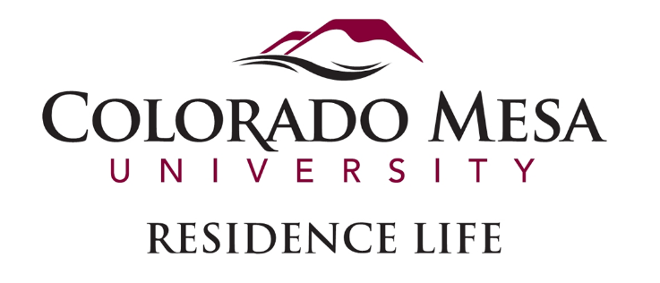

SUMMER CAMPS AND CONFERENCE ASSISTANT

Position Description

**Position Overview:**  
The Summer Camps and Conference Assistant (CA) serves as a critical link between Colorado Mesa University and its diverse range of summer conference guests. CAs are responsible for providing excellent customer service, ensuring the smooth operation of residence hall accommodations, and serving as knowledgeable resources for guests. This position involves a high level of interaction with various summer programs, including sports camps, religious groups, student orientations, and other community organizations.

CAs will work under the supervision of the Summer Conference Coordinator and Summer Conference Team-leads, contributing to a positive guest experience by addressing needs, resolving concerns, and ensuring facilities are ready for each group’s arrival. Prior Residence Life experience is not required.

**Key Responsibilities:**

* **Guest Relations & Customer Service:**
  + Represent CMU with a professional, courteous demeanor, serving as the first point of contact for conference guests.
  + Provide accurate information about campus facilities, local attractions, and community resources.
  + Handle guest inquiries, complaints, and emergency situations promptly and professionally.
* **Facility Management & Preparation:**
  + Assist with the preparation of residence hall rooms for incoming guests, including linen distribution, room inspections, and general upkeep.
  + Conduct thorough room and building inventories pre- and post-occupancy; assess and report any damages or maintenance issues.
  + Perform check-ins and check-outs, ensuring all paperwork is completed accurately.
  + Assist with cleaning, organizing, and setting up spaces for conference use (e.g., meeting rooms, lounges).
  + Maintain showrooms in ready condition for orientation tours.
* **Operational Support:**
  + Facilitate conference arrivals and departures, including handling registration, issuing keys, and guiding guests to their accommodations.
  + Serve on a rotating duty schedule, including evening and weekend shifts, to ensure the safety and security of residential facilities.
  + Monitor and manage building access, ensuring only authorized individuals enter.
  + Support conference events, activities, and special requests as needed.
  + Deliver mail and packages to guests and summer residents.
* **Team Collaboration & Communication:**
  + Participate in staff training, weekly meetings, and regular check-ins with supervisors.
  + Work collaboratively with colleagues, facilities staff, and external vendors to support conference operations.
  + Obtain pre-approval from the Summer Conference Coordinator for any outside commitments that may impact job responsibilities.
* **Administrative & Additional Duties:**
  + Complete incident reports, maintenance requests, and other documentation in a timely manner.
  + Assist with room setups for special events, including technology support (e.g., A/V equipment) if needed.
  + Educate and inform guests about university policies and safety protocols.
  + Serve as a positive ambassador of CMU, upholding all university policies, state laws, and community standards.
  + Perform other duties as assigned to support the overall success of the summer conference program.

**Compensation:**

* Guaranteed weekly stipend at $15.75 per hour for up to 35 hours per week.
* Complimentary single room accommodation in a residence hall for the duration of employment.
* Opportunities for extended employment based on performance and department needs.

**Eligibility Requirements:**

* Must be a currently enrolled undergraduate student at CMU, having completed at least 24 credit hours.
* Must be enrolled in classes for the 2025-2026 academic year.
* Minimum cumulative GPA of 2.5 at the time of application.
* Good conduct standing with Colorado Mesa University.
* Allowed to take no more than 3 online credit hours per summer term.

**Employment Timeline:**

* **10-week option:** May 20, 2024 – July 29, 2024
* **13-week option:** May 20, 2024 – August 18, 2024
* Additional employment may be available based on performance.

**Preferred Qualifications:**

* Prior experience in customer service, hospitality, or Residence Life.
* Ability to work independently and as part of a team in a fast-paced environment.
* Strong communication, problem-solving, and organizational skills.
* Flexibility to adapt to changing schedules and conference needs.
* Familiarity with event management and logistical coordination is a plus.

**Work Environment & Physical Requirements:**

* Must reside on campus for the entire duration of employment.
* Ability to lift and carry items up to 30 pounds.
* Ability to stand, walk, and navigate across campus for extended periods.

**Additional Notes:**

* This position involves a significant amount of evening and weekend work.
* Staff will have designated “all hands on deck” days based on conference schedules.
* Adherence to CMU’s dress code and conduct policies is required at all times.

**Eligibility Requirements**  
Applicants must meet the following criteria:

* Currently enrolled undergraduate student at Colorado Mesa University.
* Completed a minimum of 24 credit hours prior to the application.
* Enrolled in courses during the previous academic year.
* Maintain a cumulative GPA of 3.0 or higher at the time of application.
* Be in good conduct standing with Colorado Mesa University.

**Employment Timeline**

* Appointment period: May 19, 2025 – August 18, 2025.